EXP. NO: 25
SIMULATION OF CONVOLUTIONAL CODES AND ANALYSIS OF ENCODED OUTPUT BIT SEQUENCES USING MATLAB
Objectives:
1. To generate a binary information sequence and encode it using a convolutional encoder in MATLAB.
2. To understand the relationship between the input bit sequence, encoder memory, code rate, and encoded output sequence.
3. To analyze the structure and length of the encoded output bit sequence for a selected convolutional code.
4. To visualize and interpret the input and encoded bit sequences and verify the encoding operation.
5. To study the effect of encoder parameters such as constraint length and generator polynomials on the encoded sequence.
Procedure:
1. Open the MATLAB software and create a new script file.
2. Clear the command window, workspace, and close all previously opened figure windows.
3. Generate a random binary input sequence.
4. Define the convolutional encoder parameters.
5. Encode the input binary sequence using the convolutional encoder.
6. Store the encoded output bit sequence.
7. Display the input bit sequence using an appropriate plot.
8. Display the encoded output bit sequence using an appropriate plot.
9. Execute the MATLAB program.
10. Observe the input and encoded output bit sequences.
11. Compare the input and encoded sequences.
12. Analyze the encoding process and verify the correctness of the generated encoded output.

PROGRAM :
clc;
clear;
close all;
% Input Bits
data = randi([0 1],20,1);
% Convolutional Encoder (Rate 1/2, Constraint Length = 3)
trellis = poly2trellis(3,[7 5]);
encoded = convenc(data,trellis);
% Display
disp('Input Bits:');
disp(data');
disp('Encoded Bits:');
disp(encoded');
% Plot
figure;
subplot(2,1,1)
stem(data,'filled')
title('Input Bit Sequence')
xlabel('Bit Index')
ylabel('Bit Value')
grid on
subplot(2,1,2)
stem(encoded,'filled')
title('Convolutionally Encoded Bit Sequence')
xlabel('Bit Index')
ylabel('Bit Value')
grid on
Output:
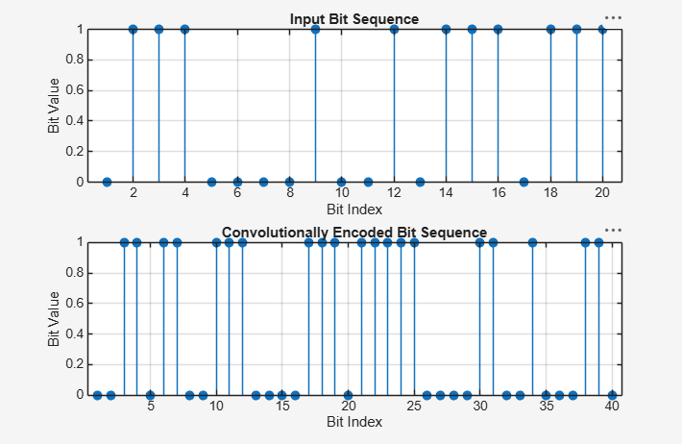

Result:
- The convolutional encoding process was successfully implemented in MATLAB, and the corresponding encoded output bit sequence was generated from the input binary sequence.
- ii) The comparison of the input and encoded bit sequences verified the correct operation of the convolutional encoder and demonstrated the introduction of redundancy for improving error correction capability.

